Stage 2 – Queries, indexes, changes, constraints, views

1. Eight queries that demonstrate practical use of the insurance database
1. Join, order by: allows us to see all the policies subscribed by customers, together with customer information.
select customer_id, policy_id, start_date
from customer natural join customers_policy
order by start_date asc;
2. Join, aggregate, group by: allows us to see the number of policies that customers subscribed to for each type of important policy (which have over 30 subscribers).
select policy.policy_id, count(*)
from policy left join customers_policy
on policy.policy_id = customers_policy.policy_id
group by policy.policy_id
having count(*) > 30;
3. Sub-query, aggregate: shows the sum of claims for policies subscribed after 01/01/2000.
select sum(amount) from (
select amount, status
from claim
where customers_policy_id in(
select customers_policy_id from customers_policy
where start_date > DATE '2000-01-01'
)
);
4. Order by: shows all the claims, sorted by submit date from oldest to most recent.
select * from claim
order by claim_date asc;
5. Sub-query: selects the name and emails of customers with the top ten bonuses.
select First_Name, Last_Name, email from Customer
where Customer_ID in (
select Customer_ID from (
select * from Customers_Policy
order by bonus desc)
where rownum <= 10);
6. Group by, aggregate: gives us a list of bad customers (of which the average of their bonuses is below 5).
select Customer_ID, avg(bonus) from Customers_Policy
group by Customer_ID
having avg(bonus) < 5;
7. Aggregate, group by: shows the count of customers for each gender.
select gender, count(*) from Customer
group by gender;
8. Aggregate, group by: shows the total price to charge for each customer.
select Customer_ID, sum(Policy.price) from Customers_Policy natural join Policy
group by Customer_ID;
2. Index and speed improvement
Here the query number 3 above is executed:
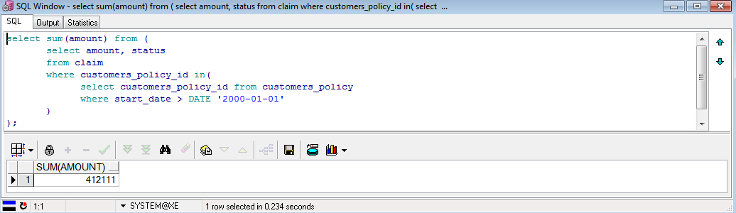
Then the Oracle server is stopped and started (cmd>net start/stop OracleServiceXE) in order to clear the buffers, which prevents unwanted cache optimization from the previous querying and we create an index over the customers_policy.start_date, which will optimize the where statement in the aforementioned query:
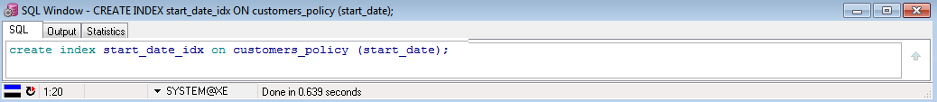
Finally, we run the query again. Notice the expected performance gain of 134ms (57%):
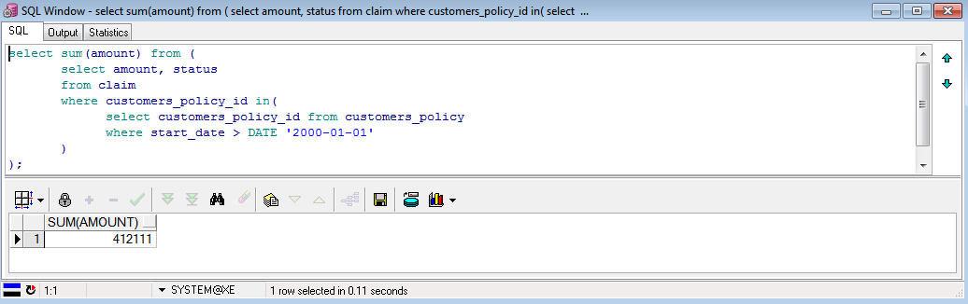

3. Two Update and two delete queries
1. Update customer’s email address:
update customer
set email = 'dacruz@anomel.com'
where customer_id = 237510106;
2. Update claim status:
update claim
set status = 0
where customers_policy_id = 153;
3. Delete claims related to customer’s policy 123:
delete claim
where customers_policy_id = 123;

4. And then delete the customer’s policy itself:
delete customers_policy
where customers_policy_id = 123;

4. Commit and rollback
1. Commit
The customer’s policy record for ID 123 looks this way before and after deletion, as long as we don’t commit:
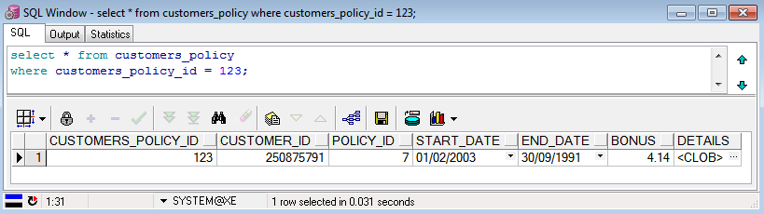
Then we execute the delete query and commit command:
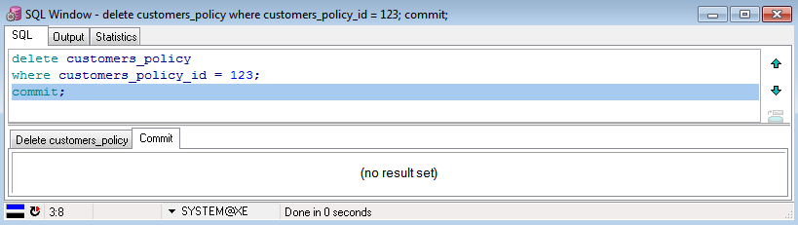
And this is what we get after commit:
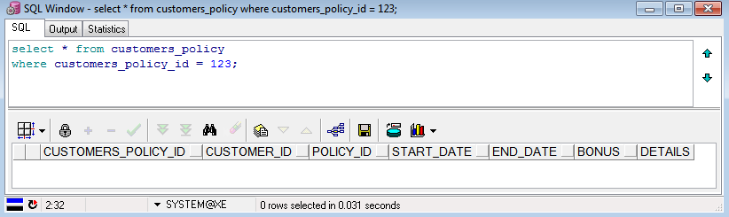
Of course, we can see that the customer’s policy record is now gone.

2. Rollback
This is what we get before deletion:
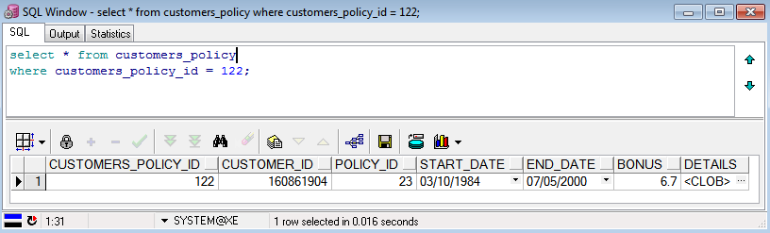
Then we delete and query:
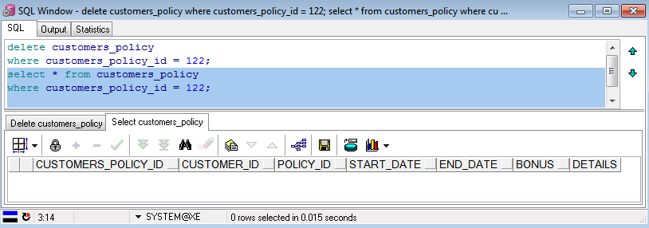
And finally rollback and query again:
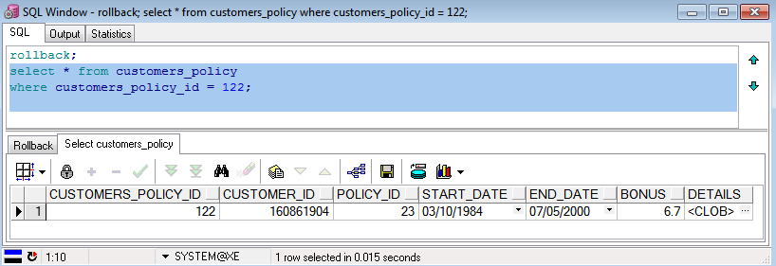
As we can see, the record has reappeared, just as expected.
5. Constraints
We define a new constraint, which checks that the customer_ID has 9 digits from 0 to 9, or in other words, that the customer_ID is strictly below 1000000000 (the lowest number with over 9 digits):
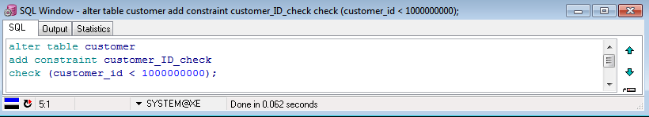
And now we update a customer’s ID with an illegal Id (1201547896, which has 10 digits):
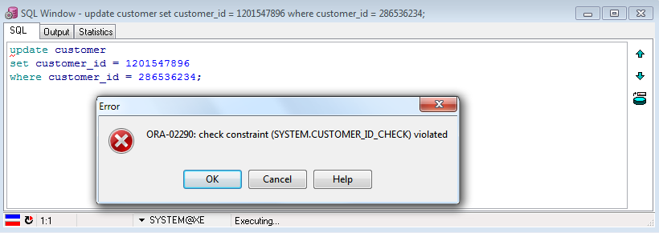
And as expected, the update is refused, because the constraint was violated.

6. Views
1. Two views
The first view shows the policy number 20:
create view policy_20 as
select * from policy
where policy_id = 20;
The second view shows the customer record information at a glance: ID, full name, number of subscribed policies and total price to pay for the month:
create view accounts as
select customer.customer_id, customer.first_name, customer.last_name,
count(*) as number_of_policies, sum(price) as total_monthly_price
from policy
join customers_policy on customers_policy.policy_id = policy.policy_id
join customer on customer.customer_id = customers_policy.customer_id
group by customer.customer_id, customer.first_name, customer.last_name;
2. Two queries:
For the first view, this query retrieves the policy ID and the price of the policy in question:
select policy_ID, price from policy_20;
And for the second, this query displays the number of customers, of customers’ policies, the total income and the average price for each customers’ policy:
select sum(customer_id) as customers, sum(number_of_policies) as policies,
sum(total_monthly_price) as income,
sum(total_monthly_price)/sum(number_of_policies) as average_policy_cost
from accounts;
3. View error
We attempt to update the total price for a given customer in the accounts view.
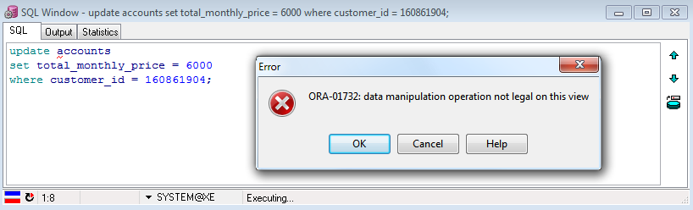
Of course, this would break the data integrity since a view’s data is not stored but is just a saved query, and we cannot update the total directly but we have to update the price of the policy type itself.

The second view retrieves the customers_policy table with only the current policies (not yet expired):
create view current_customers_policies as
select * from customers_policy
where end_date > sysdate;

